### **Infrastructure Initialisation**

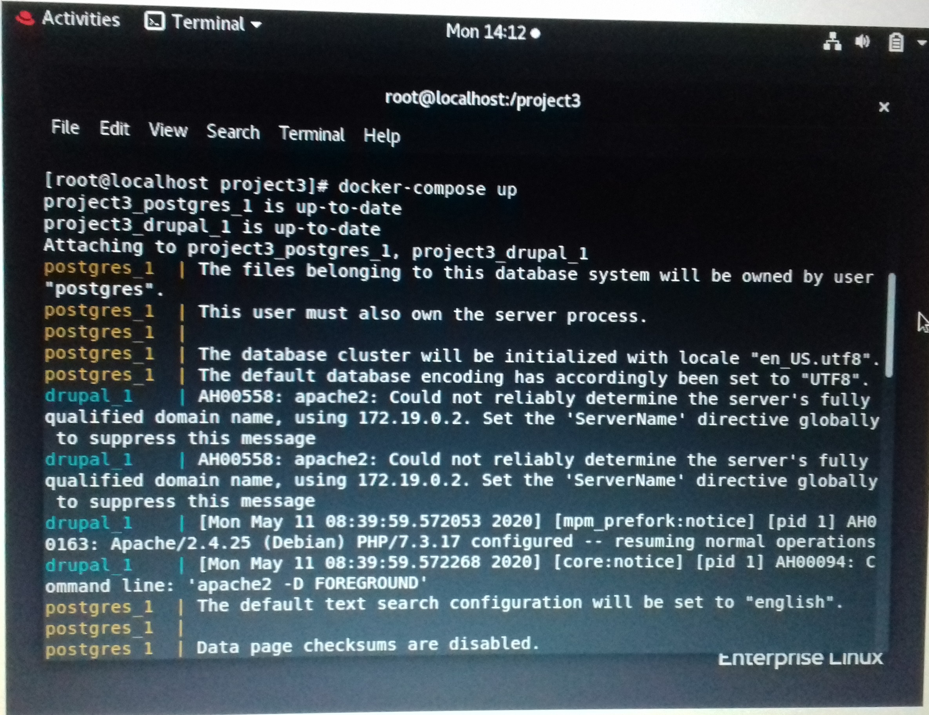1. Initiating Infrastructure setup

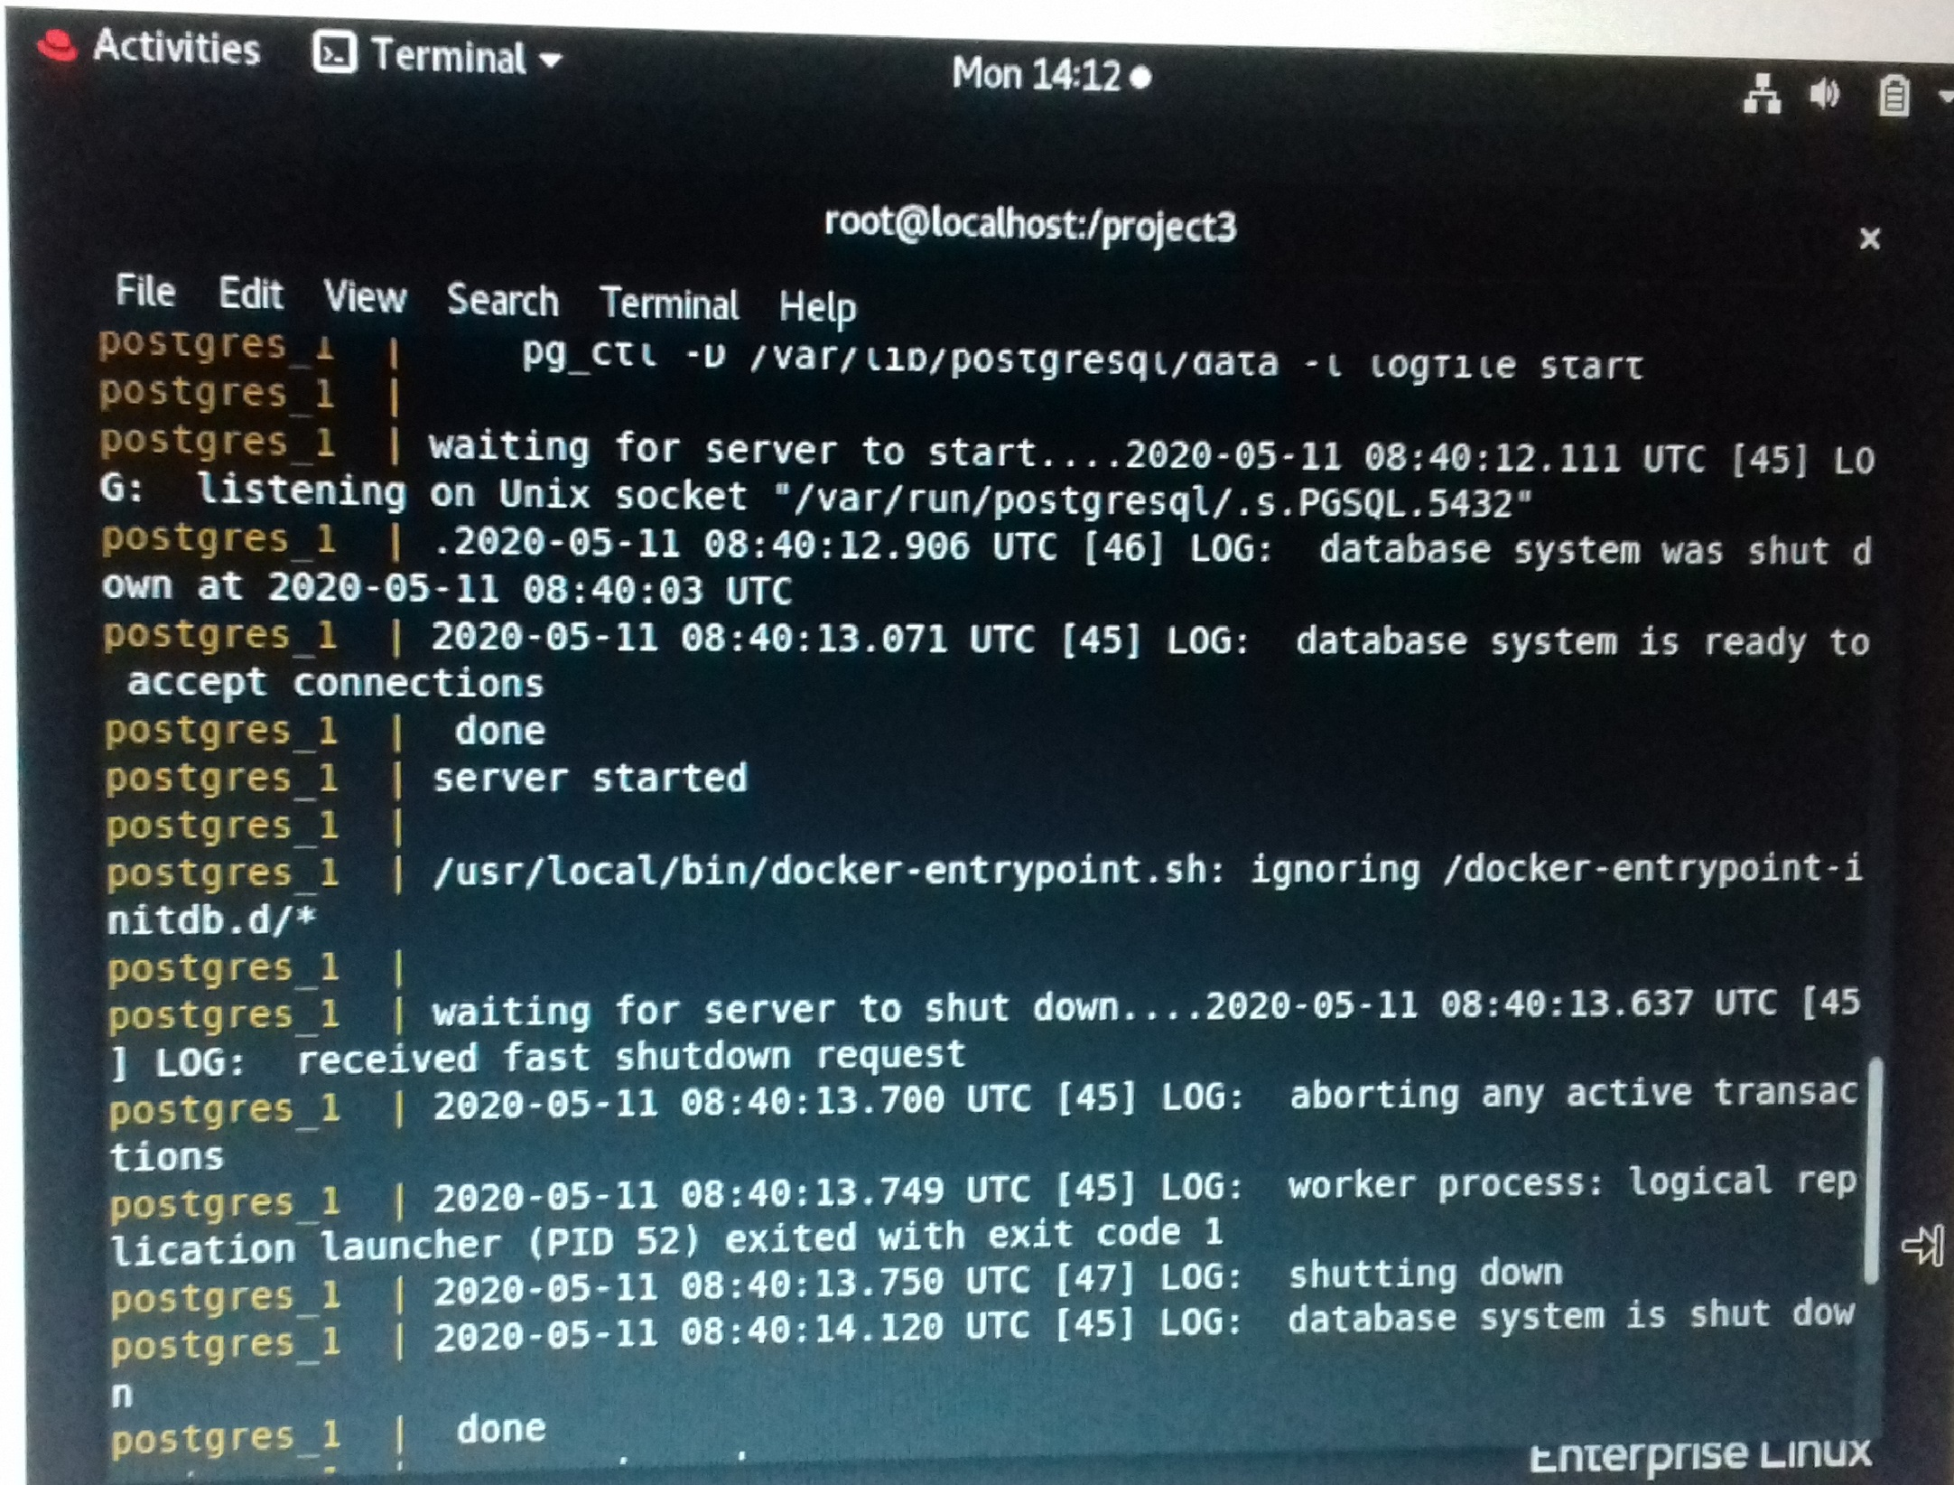

2. postgres_1 and drupal_1 Server Launch

